# Lab Manual 6

# Configurations of Router

**CLO 2**

|  |  |  |  |  |  |
| --- | --- | --- | --- | --- | --- |
| **Task** | **1** | **2** | **3** | **4** | **5** |
| **Set time and date of a router having your ID as hostname** | Student select a router | Student set the hostname of router as their respective registration ID | Student set the time and date of the system as current | Student enables user-mode password with their name | Student enables privileged-mode password with their name |
| **Router configuration** | Student designs the  network as said | Student configure the router | Student assign Class B IP address to the PCs | Student ping the default gateway | Student save the current configuration |

**Aim**:

## **Router Configuration using CLI**

Router Functions:

* + 1. IP addressing.
    2. Routing.

Router configuration modes:

1. User mode (router>).
2. Privilage mode (router #).
3. Global configuration mode (router (config)#).

**User EXEC Mode:**

When you are connected to the router, you are started in user EXEC mode. The user EXEC commands are a subset of the privileged EXEC commands.

**Privileged EXEC Mode:**

Privileged commands include the following:

* Configure – Changes the software configuration.
* Debug – Display process and hardware event messages.
* Setup – Enter configuration information at the prompts.

Enter the command disable to exit from the privileged EXEC mode and return to user EXEC mode.

**Configuration Mode:**

Configuration mode has a set of submodes that you use for modifying interface settings, routing protocol settings, line settings, and so forth. Use caution with configuration mode because all changes you enter take effect immediately.

To enter configuration mode, enter the command configure terminal and exit by pressing Ctrl-Z.

**Getting Help:**

In any command mode, you can get a list of available commands by entering a question mark (?).

**Router>?**

To obtain a list of command that begin with a particular character sequence, type in those characters followed immediately by the question mark (?).

We use packet tracer program for router configuration in the previous 3 modes. We choose a router: Now we are in the user mode:

To know the commands in user mode we use (?) :

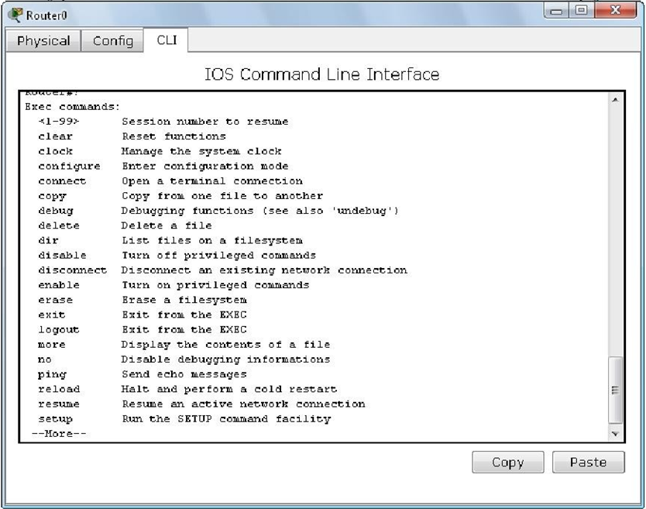

Enter the privileged Mode and To manage the system clock, we use (clock):

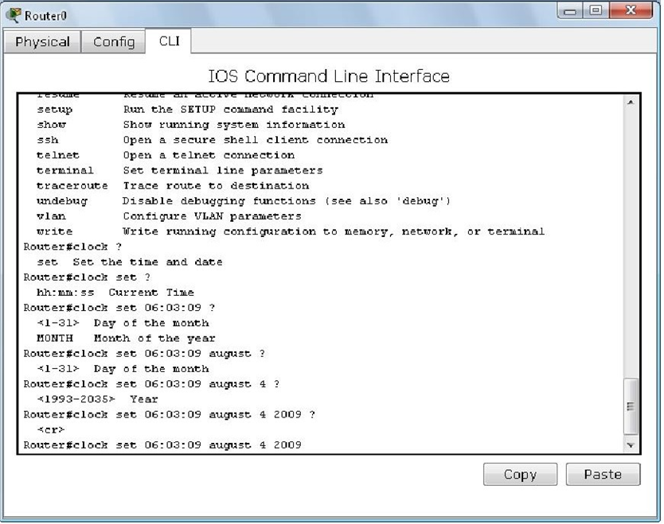

To see the time, we use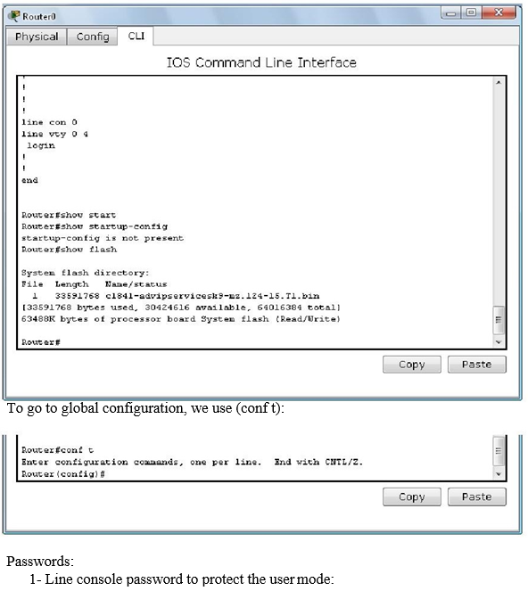 (show clock):

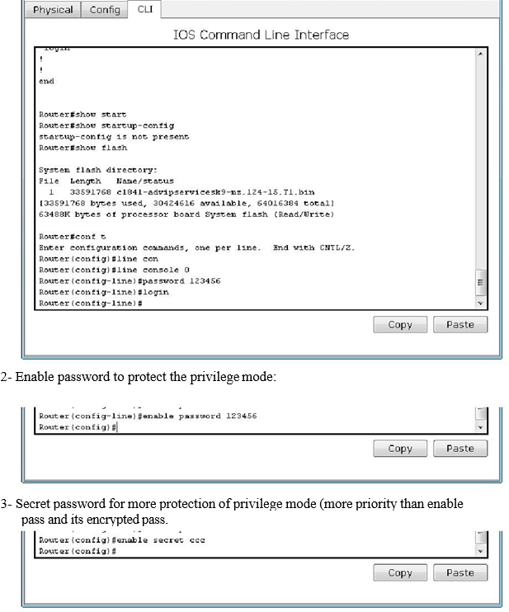

Now we try the passwords set:

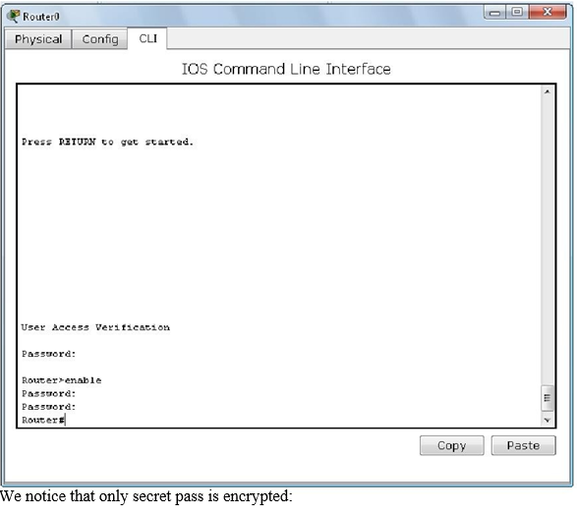

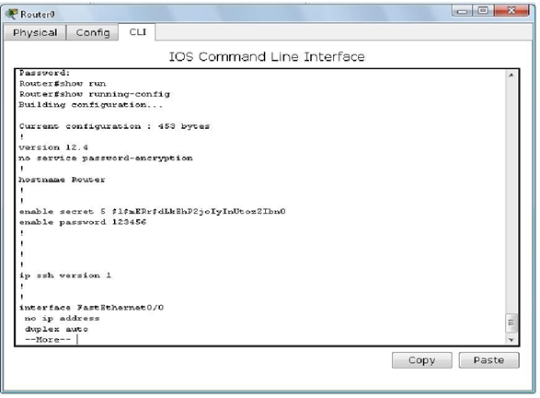

To save the configuration we did in the NVRAM we use (wr or copy commands).

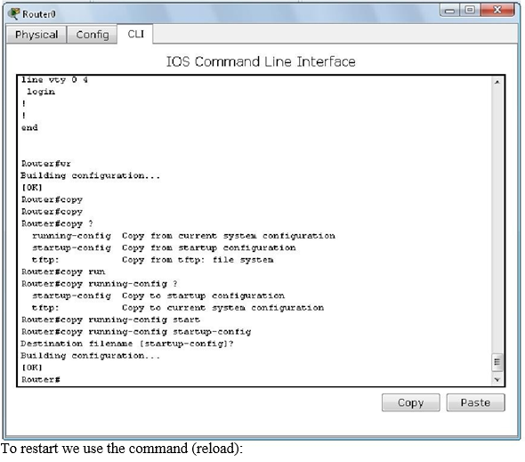

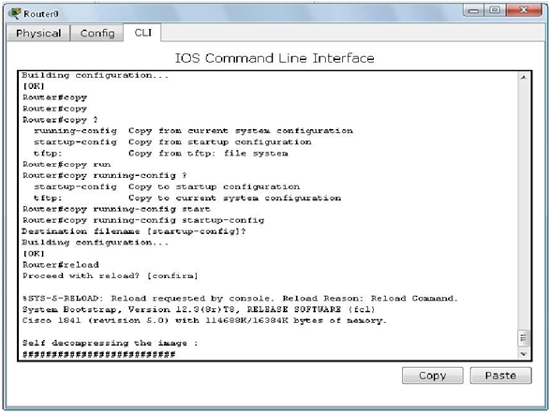

To change hostname of the router:

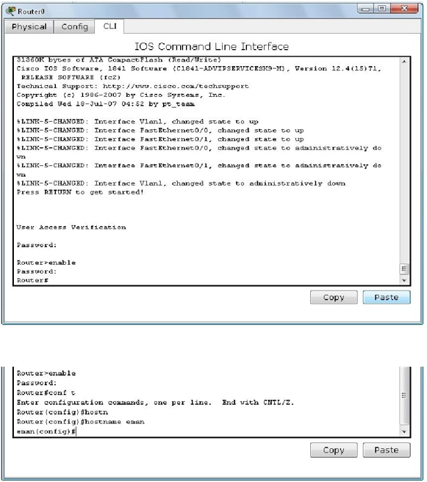

Now to assign the IP’s to the interface of the router:

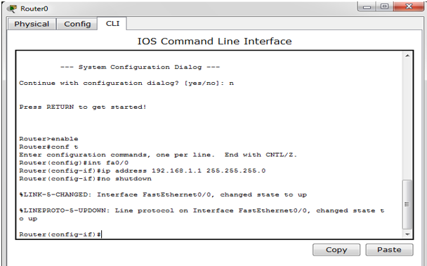

And to make sure of the IP’s (‘’Router#show int fa0/0’’):

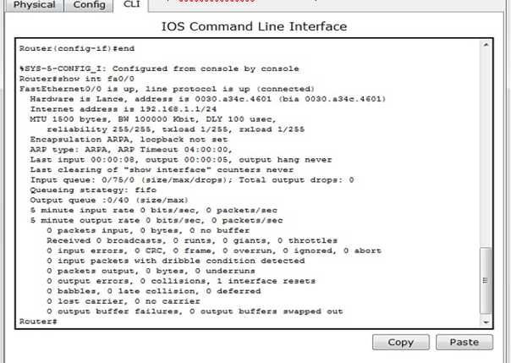

**Task 1:**

Choose a router in packet tracer. Name it with your registration # e.g., 2018-CS-XX. Set its Time and Date as today. Enable user mode and privileged mode passwords with your name.

**Task 2:**

Design a network having one router and two PC’s as shown in the figure. Configure the router and also assign the **Class C** IP addresses to the PC’s and ping the default gateway. Also save the current configuration of the router.



